**Lab 2 jQuery**

**Name: Ketan Goud**

**Reg No: 220905260**

**Section: CSE D D2**

**Roll No: 39**

1. **Write a web page which contains table with 3 X 3 dimensions (fill some data) and one image. Style the rows with alternate colour. Move the table and image together from right to left when button is clicked.**

<!DOCTYPE html>

<html lang="en">

<head>

<meta charset="UTF-8">

<meta name="viewport" content="width=device-width, initial-scale=1.0">

<title>Table and Image Movement</title>

<script type="text/javascript" src="jquery-3.7.1.min.js"></script>

<style>

body {

font-family: Arial, sans-serif;

padding: 20px;

background-color: #f4f4f4;

text-align: center;

}

table {

width: 300px;

border-collapse: collapse;

margin-bottom: 20px;

}

table, th, td {

border: 1px solid #ccc;

}

th, td {

padding: 10px;

text-align: center;

}

/* Alternating row colors */

tr:nth-child(odd) {

background-color: #f2f2f2;

}

tr:nth-child(even) {

background-color: #e9e9e9;

}

img {

width: 300px;

height: 200px;

margin-top: 20px;

}

#container {

position: relative;

width: 100%; /* Ensure the container takes full width */

}

/* Set initial position for the table and image */

#table, #image {

position: relative;

top: 0;

}

/* Adjust image to be below the table */

#image {

margin-top: 20px; /* Adjust this if needed based on your table height */

}

button {

padding: 10px 20px;

background-color: #4CAF50;

color: white;

border: none;

cursor: pointer;

margin-top: 40px; /* Ensure it is positioned below the table and image */

}

button:hover {

background-color: #45a049;

}

</style>

</head>

<body>

<h2>Table and Image Movement Example</h2>

<div id="container">

<!-- Table -->

<table id="table" align="center">

<tr>

<th>Header 1</th>

<th>Header 2</th>

<th>Header 3</th>

</tr>

<tr>

<td>1</td>

<td>2</td>

<td>3</td>

</tr>

<tr>

<td>4</td>

<td>5</td>

<td>6</td>

</tr>

<tr>

<td>7</td>

<td>8</td>

<td>9</td>

</tr>

</table>

<!-- Image -->

<img id="image" src="/home/lab1/220905260/Lab 2/img.jpg" alt="Placeholder Image">

</div>

<!-- Button to trigger the movement -->

<button id="moveBtn">Move Right to Left</button>

<script>

$(document).ready(function() {

// Button click event to move table and image

$("#moveBtn").click(function() {

// Move both the table and the image together

$("#table, #image").animate({

left: "-=500px" // Move them 500px to the left

}, 2000); // The animation will take 2 seconds

});

});

</script>

</body>

</html>

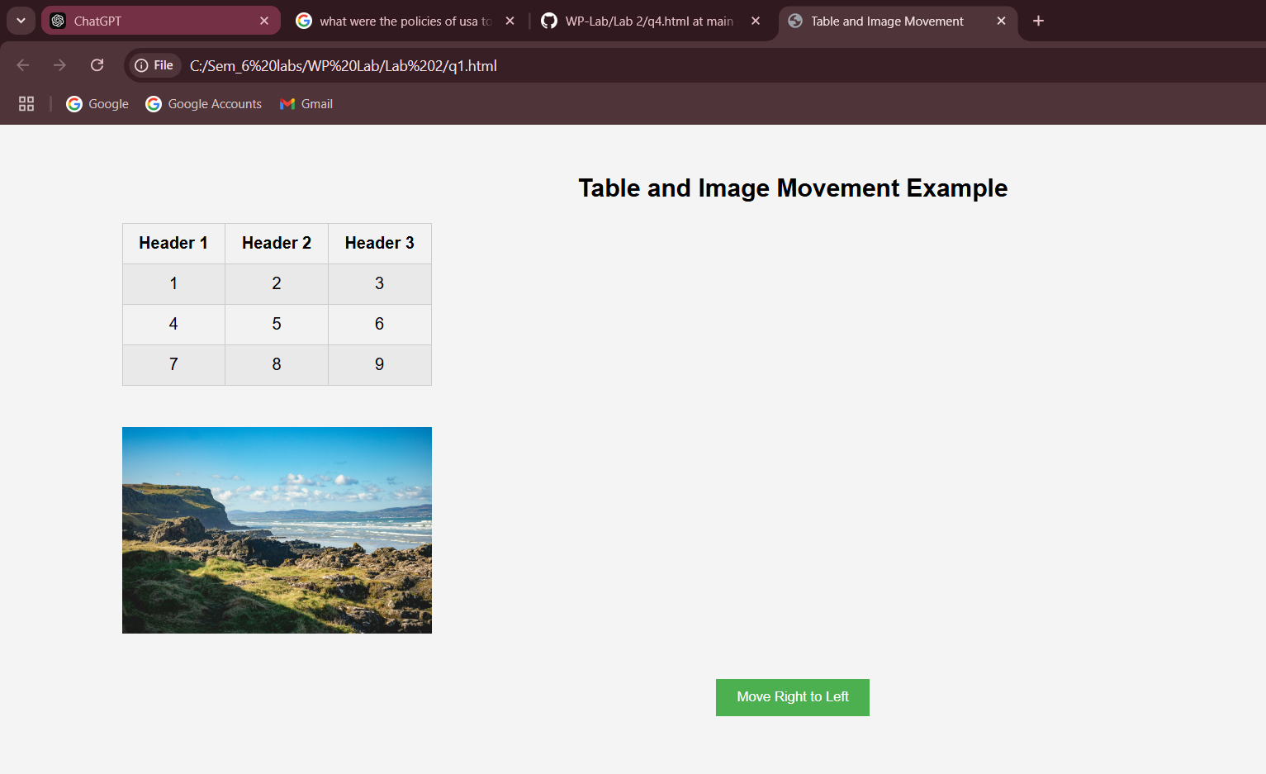

1. **Design a calculator to perform basic arithmetic operations. Use textboxes and buttons to design web page.**

<!DOCTYPE html>

<html lang="en">

<head>

<meta charset="UTF-8">

<meta name="viewport" content="width=device-width, initial-scale=1.0">

<title>Simple Calculator</title>

<script type = "text/javascript" src="jquery-3.7.1.min.js"></script>

<style>

input, button

{

padding: 10px;

font-size: 18px;

margin: 5px;

}

#display

{

width: 200px;

text-align: right;

}

button

{

width: 45px;

height: 45px;

}

</style>

</head>

<body>

<input type="text" id="display" disabled>

<br>

<button class="btn">1</button>

<button class="btn">2</button>

<button class="btn">3</button>

<button class="btn">+</button>

<br>

<button class="btn">4</button>

<button class="btn">5</button>

<button class="btn">6</button>

<button class="btn">-</button>

<br>

<button class="btn">7</button>

<button class="btn">8</button>

<button class="btn">9</button>

<button class="btn">*</button>

<br>

<button class="btn">0</button>

<button id="clear">C</button>

<button id="equals">=</button>

<button class="btn">/</button>

<script>

$(document).ready(function() {

// Append number or operator to the display

$(".btn").click(function() {

var value = $(this).text();

$("#display").val($("#display").val() + value);

});

// Clear the display

$("#clear").click(function() {

$("#display").val('');

});

// Calculate the result

$("#equals").click(function() {

var expression = $("#display").val();

try {

var result = eval(expression);

$("#display").val(result);

} catch (e) {

$("#display").val('Error');

}

});

});

</script>

</body>

</html>

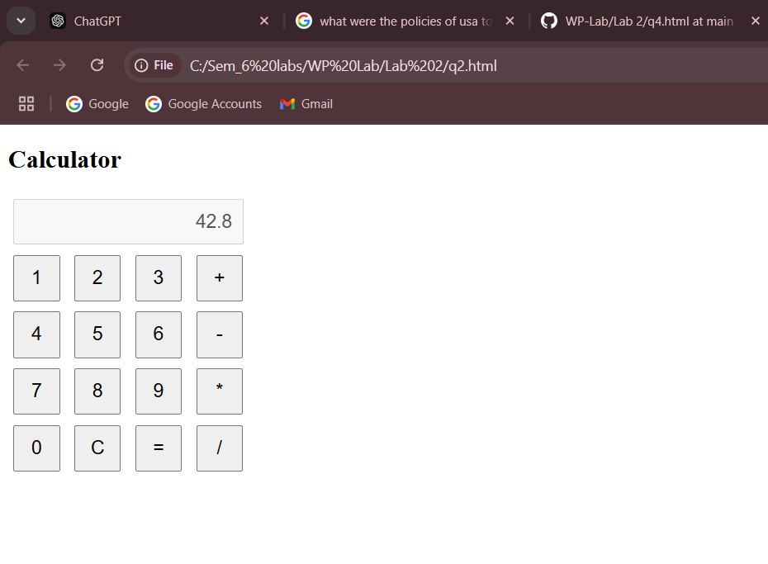

1. **Create a web page to design a birthday card shown below.**

<!DOCTYPE html>

<html lang="en">

<head>

<meta charset="UTF-8">

<meta name="viewport" content="width=device-width, initial-scale=1.0">

<title>Card Customizer</title>

<link rel="stylesheet" href="https://cdnjs.cloudflare.com/ajax/libs/font-awesome/5.15.4/css/all.min.css">

<style>

body {

display: flex;

font-family: Arial, sans-serif;

margin: 0;

padding: 20px;

}

#options {

width: 50%;

padding-right: 20px;

}

#card {

width: 50%;

border: 1px solid #ccc;

padding: 20px;

box-shadow: 0 0 10px rgba(0, 0, 0, 0.1);

}

#card img {

max-width: 100%;

height: auto;

}

</style>

</head>

<body>

<div id="options">

<h2>Customize Your Card</h2>

<label for="bgColor"> Choose your Background Color:</label>

<select id="bgColor">

<option value="#ffffff">White</option>

<option value="#ffcccb">Light Red</option>

<option value="#ccffcc">Light Green</option>

<option value="#add8e6">Light Blue</option>

</select>

<br><br>

<label for="font">Choose your Font:</label>

<select id="font">

<option value="Arial">Arial</option>

<option value="Courier New">Courier New</option>

<option value="Georgia">Georgia</option>

<option value="Times New Roman">Times New Roman</option>

</select>

<br><br>

<label for="fontSize">Choose your Font Size:</label>

<input type="number" id="fontSize" value="16" min="10" max="50"> px

<br><br>

<label>Select your Border Style:</label><br>

<input type="radio" name="border" value="none" checked> None<br>

<input type="radio" name="border" value="solid"> Solid<br>

<input type="radio" name="border" value="dashed"> Dashed<br>

<input type="radio" name="border" value="dotted"> Dotted<br>

<br>

<label>

<input type="checkbox" id="defaultImage"> Add Default Picture

</label>

<br><br>

<label for="greetingText">Greeting Text:</label><br>

<textarea id="greetingText" rows="4" cols="30"></textarea>

<br><br>

<button id="updateCard">Update Card</button>

</div>

<div id="card">

<div id="cardContent">

<p>Your greeting will appear here.</p>

</div>

</div>

<script type="text/javascript" src="jquery-3.7.1.min.js"></script>

<script>

$(document).ready(function() {

$('#updateCard').click(function() {

// Get values from inputs

var bgColor = $('#bgColor').val();

var font = $('#font').val();

var fontSize = $('#fontSize').val() + 'px';

var borderStyle = $('input[name="border"]:checked').val();

var greetingText = $('#greetingText').val();

var defaultImage = $('#defaultImage').is(':checked');

// Update card styles

$('#cardContent').css({

'background-color': bgColor,

'font-family': font,

'font-size': fontSize,

'border': borderStyle === 'none' ? 'none' : '2px ' + borderStyle + ' black',

'padding': '10px'

});

// Update greeting text

$('#cardContent').html(greetingText || 'Your greeting will appear here.');

// Add default image if checked

if (defaultImage) {

$('#cardContent').prepend('<img src="/home/lab1/220905260/Lab 2/119.jpg" alt="Default Image"><br>');

} else {

$('#cardContent img').remove();

}

});

});

</script>

</body>

</html>

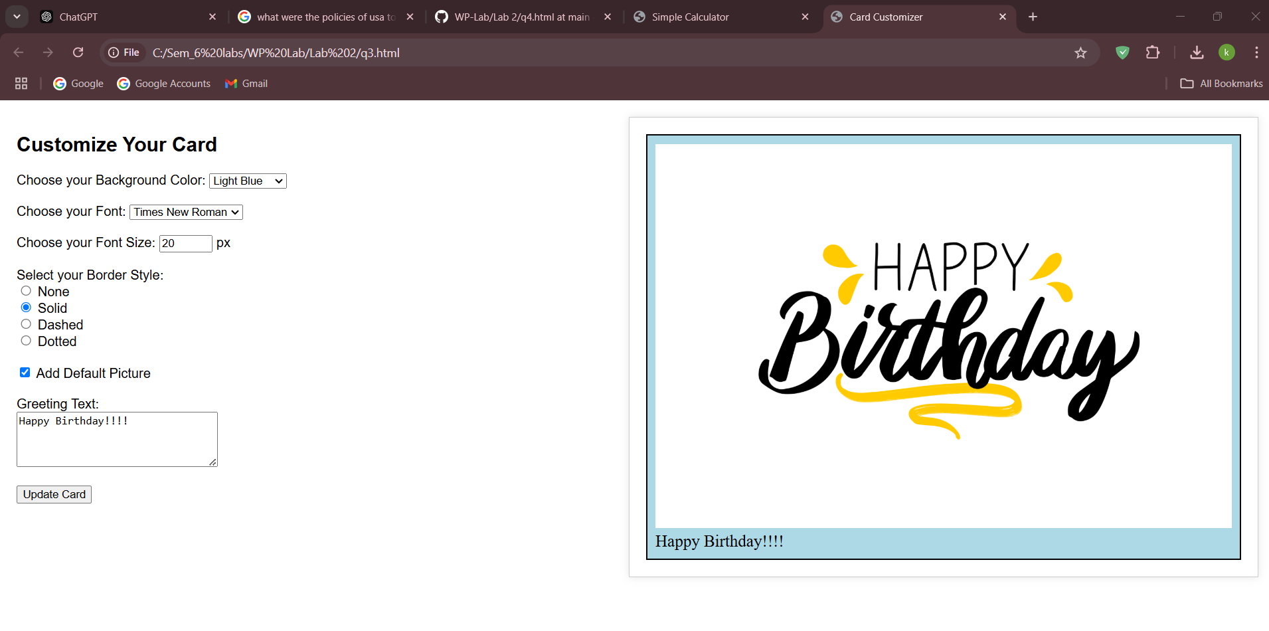

1. **Design a webpage. The page contains:**

**Dropdown list with HP, Nokia, Samsung, Motorola, Apple as items.**

**Checkbox with Mobile and Laptop as items.**

**Textbox where you enter quantity.**

**On Clicking Produce Bill button, alert should be displayed with total amount.**

<!DOCTYPE html>

<html lang="en">

<head>

<meta charset="UTF-8">

<meta name="viewport" content="width=device-width, initial-scale=1.0">

<title>Bill Generator</title>

<script src="https://code.jquery.com/jquery-3.6.0.min.js"></script>

<style>

body {

font-family: Arial, sans-serif;

padding: 20px;

background-color: #f4f4f4;

}

.container {

background-color: white;

padding: 20px;

border-radius: 8px;

box-shadow: 0 0 10px rgba(0, 0, 0, 0.1);

width: 300px;

}

input, select, button {

width: 100%;

padding: 10px;

margin: 10px 0;

}

button {

background-color: #4CAF50;

color: white;

border: none;

cursor: pointer;

}

button:hover {

background-color: #45a049;

}

.checkbox-group {

margin: 10px 0;

}

</style>

</head>

<body>

<div class="container">

<h3>Generate Bill</h3>

<!-- Dropdown List -->

<label for="brand">Select Brand:</label>

<select id="brand">

<option value="HP">HP</option>

<option value="Nokia">Nokia</option>

<option value="Samsung">Samsung</option>

<option value="Motorola">Motorola</option>

<option value="Apple">Apple</option>

</select>

<!-- Checkbox List -->

<div class="checkbox-group">

<label><input type="checkbox" id="mobile"> Mobile</label><br>

<label><input type="checkbox" id="laptop"> Laptop</label><br>

</div>

<!-- Quantity Textbox -->

<label for="quantity">Enter Quantity:</label>

<input type="number" id="quantity" min="1" required>

<!-- Produce Bill Button -->

<button id="produceBill">Produce Bill</button>

</div>

<script>

$(document).ready(function() {

// Price list for each item type

var prices = {

"HP": { "Mobile": 300, "Laptop": 800 },

"Nokia": { "Mobile": 200, "Laptop": 700 },

"Samsung": { "Mobile": 350, "Laptop": 900 },

"Motorola": { "Mobile": 250, "Laptop": 750 },

"Apple": { "Mobile": 600, "Laptop": 1500 }

};

// On clicking "Produce Bill"

$("#produceBill").click(function() {

var brand = $("#brand").val(); // Get selected brand

var quantity = $("#quantity").val(); // Get entered quantity

// Check if quantity is valid

if (!quantity || quantity <= 0) {

alert("Please enter a valid quantity.");

return;

}

var totalAmount = 0;

var itemsSelected = false;

// Check if Mobile is selected

if ($("#mobile").is(":checked"))

{

totalAmount += prices[brand]["Mobile"] * quantity;

itemsSelected = true;

}

// Check if Laptop is selected

if ($("#laptop").is(":checked"))

{

totalAmount += prices[brand]["Laptop"] * quantity;

itemsSelected = true;

}

// If no items are selected, show alert

if (!itemsSelected)

{

alert("Please select at least one item (Mobile or Laptop).");

return;

}

// Display the total amount in an alert

alert("Total Amount: $" + totalAmount);

});

});

</script>

</body>

</html>

